1. **Setup JDK and environment variable** 
   1. Donwload and install JDK
   2. Create new system variable: **JAVA_HOME**

Value: JDK path, ex : C:\Program Files\Java\jdk1.8.0_131)

* 1. Edit Path variable: add at last: %JAVA_HOME%\bin;

1. **Setup Maven and environment variable**
   1. Download and install apache-maven-3.6.0, get latest
   2. Create new system variable: **M2_HOME**

Value: (path where you extracted maven folder)

* 1. Edit Path variable: add at last: %M2_HOME%\bin;
  2. Check Maven installed successfully: cmd.exe -> mvn –v

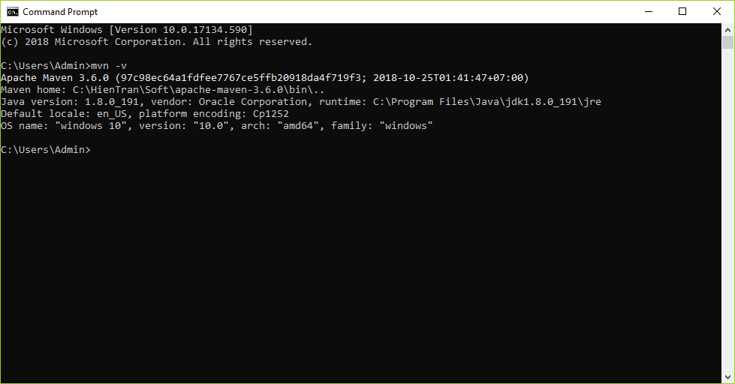

1. **Setup Eclipse**

Download eclipse-jee, get latest

Config eclipse

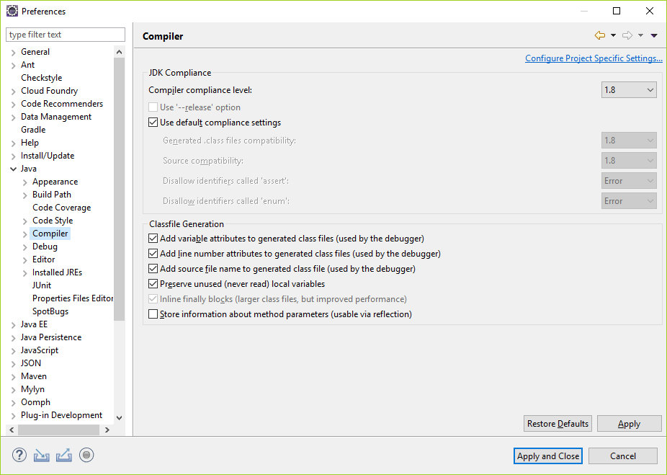

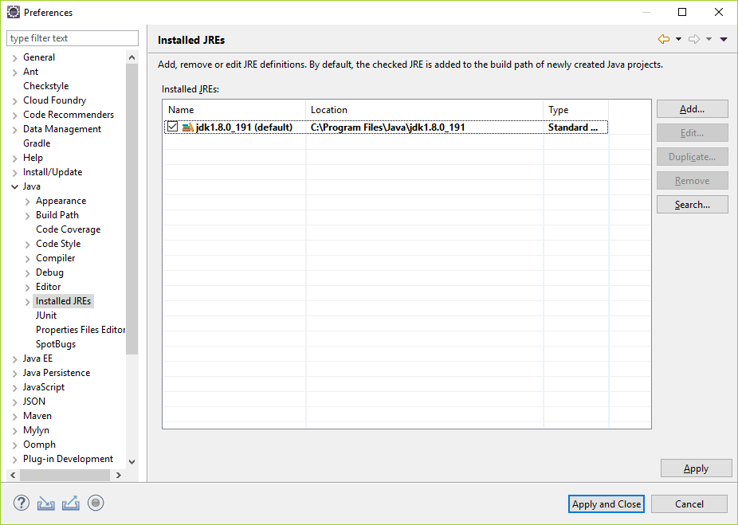

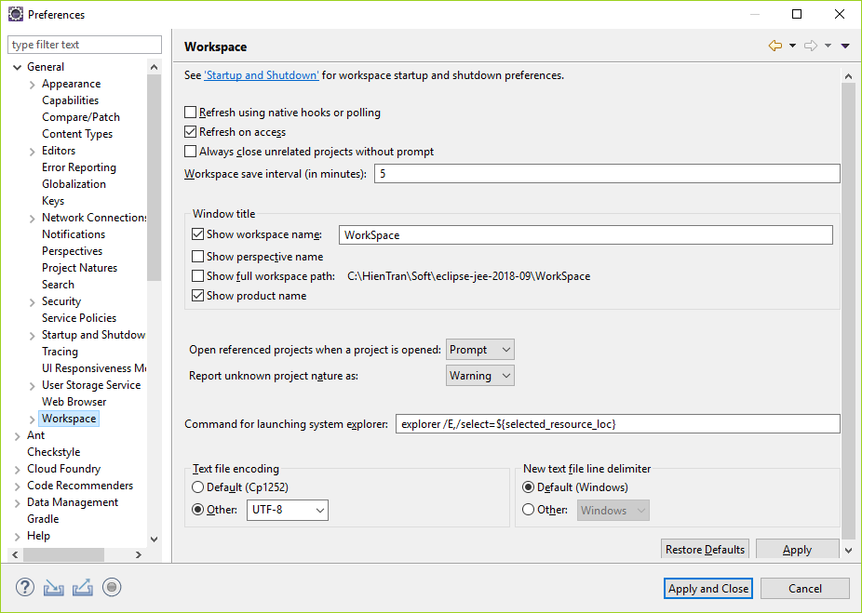

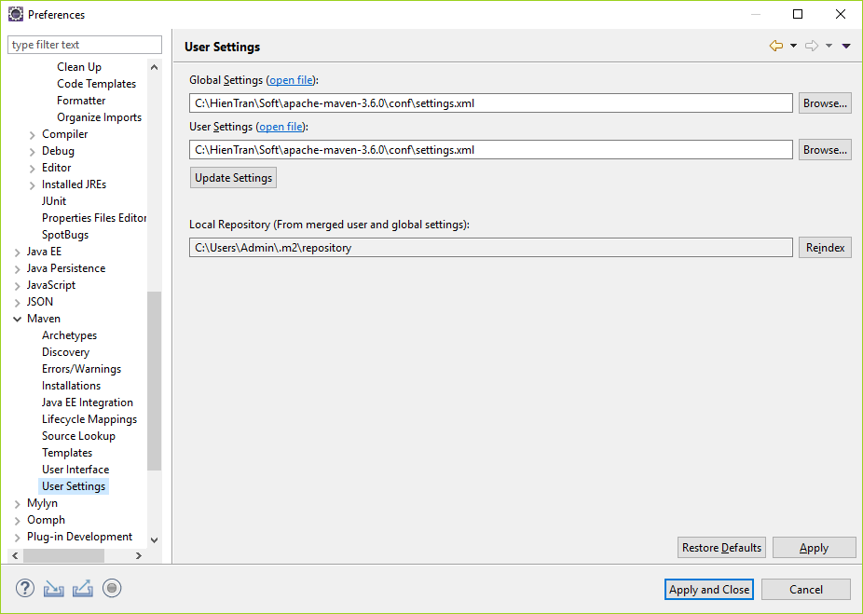

Import Code_Templates.xml

Import Code_Formatter.xml

**Project**

* Download and import existence maven project
* FindBug